MATH 245 Simulation Problem #2

Javier Jesús Macossay-Hernández

1. Plot of response curve and phase portrait

ωf = 1/2

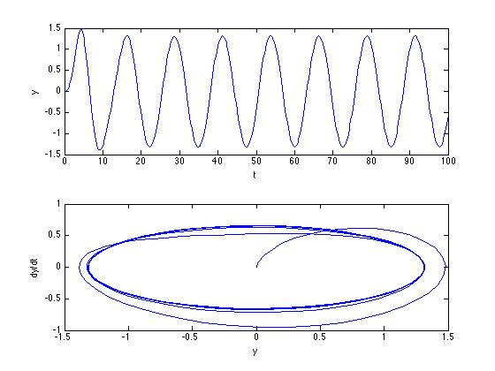

ωf = 1

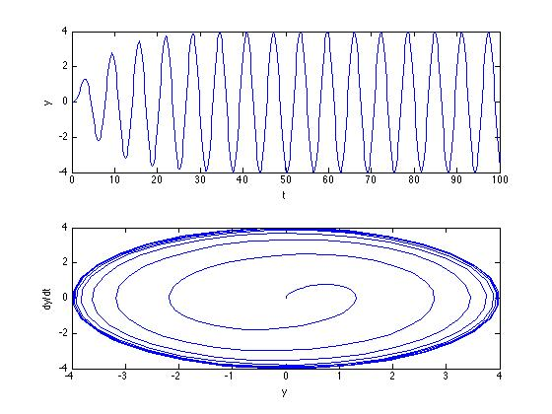

ωf = 2

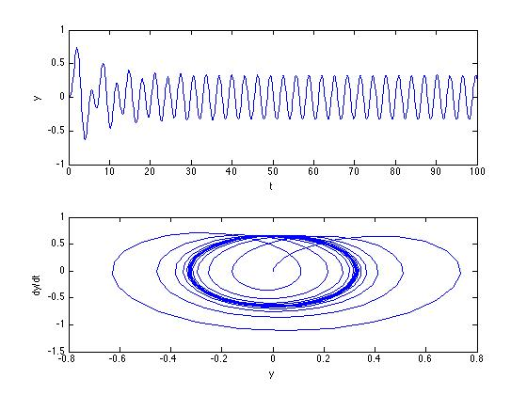

1. Comparison table for the peak amplitude and the phase shift

|  |  |  |  |
| --- | --- | --- | --- |
| ωf | 1/2 | 1 | 2 |
| Peak Amplitude | 1.31519 | 4 | 0.328798 |
| Phase Shift | 9.46° | 90° | -9.46° |

1. Briefly explain why we have the largest peak amplitude at the case of ωf = 1 ?

When ωf = 1, we have resonance. At resonance we have the maximum response from our system and the amplitude of the response is a function of the value of λ (lambda), which is the damping coefficient. λ is inversely proportional to the time needed to make the homogeneous solution equal to zero. By looking into the formula given to calculate the amplitude of the steady state, which depends on the particular solution, we can prove that the peak amplitude is the largest because is inversely proportional to the denominator. The denominator gets to its smaller value when the forcing frequency is equal to the natural frequency. Both terms cancel and we get the largest peak amplitude.

4)

ODE function file-

function dy = fodehw(t,y)

lmd = 1/8;

omg = 1;

omgf = 2;

f0 = 1;

dy = [y(2)

f0*sin(omgf*t)-2*lmd*omg*y(2)-omg^2*y(1)];

Main program-

%simulation forced response of 2nd order ODE

tspan = [0 100];

init = [0,0];

[t,y]=ode45(@fodehw,tspan,init);

%plot y(t)

figure

subplot(2,1,1)

plot(t,y(:,1))

xlabel('t');

ylabel('y');

%plot phase portray

subplot(2,1,2)

plot(y(:,1),y(:,2))

xlabel('y');

ylabel('dy/dt');